# INDEX of pages

Cover Page & Index 1

Overview & Subtitles #1-6 2 #1 Project #2 Scope #3 Requirements #4 Deliverables #5 Affected Parties #6 Businesses

Subtitles #7-10 3 #7 Exclusions #8 Implementations #9 Timetable #10 Protocols

EEP Task Force Contacts 4

On Being Faithful Survey & Response 5

Pictures & Indicators 6-7

Diocesan Season II Re-Entry Reponses 8-10

Revised Changed Usher Instructions 11

Safety & Check-In Volunteer Instructions 12

Screening Checklist & Health Questions 13

Social Media & E-News Information 14

Procedures for Shutdown & Deep Cleaning 14

Diagram – Church 15 (see attachment)

Diagram – Parish Hall / School 16 (see attachment)

# Overview

## Project Background and Description

In response to: 1) the request from the Episcopal Diocese of SE Florida for each church to have available its own policy/procedure for emergency following a pandemic and the for re-opening of facilities and adhering to the Diocesan model; 2) the need for an on-site plan with photographs; 3) the need for a cohesive core committee for Extraordinary Emergency Planning (EEP) and its EEP Task Force.

## Project Scope

## Following the Diocese of Southeast Florida Re-Gathering *On Being Faithful policy, Executive Summary, and Re-Entry Checklist* mandates and recommendations for our return to in-person attendance at mass, during phasing-in, with restrictions related to keeping our parish healthy and thriving as we learn to live with the virus in our midst. A re-opening plan and committee was formed and put into action. Following Season I, Season II, and Season III of the Diocesan plans, we model our EEP accordingly.

The design and implementation of a plan that gives easy and quick access to designated responders prior, during and after an emergency. The primary objectives are to: 1) assess how best to implement the diocesan policy as applied to our particular situation, groups, masses, meetings, communicants, community and guests; 2) widely and completely disseminate all pertinent information to our people using all communication vehicles accessible; 3) ensure and maintain a high quality of safety and cleanliness for all individuals; 4) be prepared to re-closed if deemed necessary.

## High-Level Requirements

Plan with photographs are included according to the majority of issues that potentially can occur here and are common to St. David’s Church. The new plan must include the following, but at writing is not all inclusive or exclusive:

* Ability to allow both internal and external users to access the plan without delay or duplication of efforts.
* Ability to interface with the existing data and core committees quickly
* Ability to incorporate automated notifications (communications flow) from both primary and secondary sources

## Deliverables

A plan to assist those impacted by an unexpected shut-in to re-opening plan– this plan will outline how and on whom it be implemented; those affected include. In the event of a second complete shut-down due to diocesan, government or occurrence of an attendee contracting the virus after the re-opening, the diocesan plan will be adhered to and key persons will be notified along with all social media notifications and emails or direct phone calls to those without.

* Staff of both Church and School, Parishioners, Community Groups
* The plan includes provision to ensure that all staff and key personnel have current contact list and flow chart

## Affected Parties – business processes/systems impacted

People who frequent the Church, School and Offices (masses, events, services, sessions) attendance and accessibility (12-step meetings, events, mass/services, ministry meetings, school, vendors, etc.)

## Affected Business Processes or Systems or Groups

All non-essential business of office work is either postponed or done remotely. All necessary work is conducted on-site after disinfecting procedures are followed and continued thereafter. Data processing, accounting, collections, bookkeeping, telecommunication, social media is mainly done remotely, to the exception of the collection of financial donations and making of deposits. Other work done at discretion of rector and administrator.

## Specific Exclusions from Scope

Implementation of this new plan begins with the publishing of an easy-access handbook with communications flow chart, after recruiting core committee. Expansion with details will commence thereafter, and be perpetually updated.

## Implementation Plan

Much can be accomplished to minimize the effect (virus or otherwise) of an unexpected outbreak when we collaborate effectively and efficiently to safeguard what we have. Church has been sectioned off using 6-foot 360°. Parish Hall/School will be marked off at a later date by School Director & Administrator/Sexton.

## Timeline/Schedule

Much of this plan is already in progress and/or has been initiated or soon will be and is expected to be updated as time goes on. This plan is meant to be fully applied as soon as permitted by the Bishop of the Diocese of SE Florida Episcopal Church on or before June 19, 2020 so that we my possibly re-open church the first week of July. Otherwise, if the Bishop extends the re-opening we will work accordingly to each new date.

## Protocols: Tasks to be Completed - Responsible Person – When Performed – Limit of People in Buildings/Rooms

Protocols – created & designed by Administrator/Sexton, approved by Rector, agreed upon by Vestry, supported by EEP Task Force.

* Deep cleaning performed by janitorial vendor for all rooms in both buildings
* Contractual janitorial cleaning performed two times a week (Wednesday & Saturday) in each building without school or community groups meeting; seven times a week in Parish Hall (PH) and School (M-F) when in session or community groups meet and 2 times a week in Church building (Wed. & Sat.).
* In-between cleaning of multiple mass services, functions, meetings, sessions, office work will be cleaned:
  + Offices & Restrooms associated with - those using it before they leave.
  + Church Narthex, Nave & Restrooms associated with – Safety Volunteers, Task Force, Vestry
  + Music Suite of Church – those using it before they leave, volunteers
  + Sacristy Priest, Altar, Eucharistic Ministers Vesting Room – Altar Guild volunteers
  + School & Restrooms associated with - by teachers, assistants, or volunteers.
* Supplies locations (when about to run out, ask Sexton/Admin to replenish):
* Kinds of Supplies on hand – masks, gloves, mitts, cloths, bleach, disinfectant spray, wipes, paper towels, tissue, spray, sanitizer, hand soap, liners
  + PH Offices – in each office
  + Church, Music Suite, Sacristy, Altar, Vesting Room - narthex
  + School - designated by director

Number of People Per Building/Room: (No physical touching, continual mask-wearing)

Nave ( including Transept & Organ Choir **50** (marked & roped accordingly, reserved seating)

Offices **1-2** Music Suite **1** Sacristy **1** Vesting Room EM **1**

Church Men’s RR **1** Church Women’s RR **2**

Parish Hall RR Men’s **1** Parish Hall RR **1-2**

Areas to be regularly cleaned above: all common touch points, doors, knobs, handles, light switches, counters, pew tops/ends, altar, office equipment & machines, organ keys/stops, copiers, tables/chairs, restroom stall door handles & catches, toilet flushers, faucets, counters, and similar frequent common touch points.

Note: supplies in janitorial closet belong to vendor.

# Approval and Authority to Proceed *“EEP Task Force”*

|  |  |  |
| --- | --- | --- |
| Name | Title | Mobil Cell |
| Rev. Steven Thomas | Rector | 561-793-7788 |
| Suzanne Riddle | Administrator, Sexton | 561-644-2687 |
| Michael Riddle | Men’s Group, Choir | 318-548-0689 |
| Laurie Cohen | Legal Counsel | 561-252-9828 |
| Erin Thomas | Nursery, Sunday School | 305-216-6646 |
| Howard Barrett | Vestry, Sr. Warden | 917-837-2675 |
| Joyce Parker | Outreach, DOK | 561-312-2719 |
| Kenneth Barnett | Ushers | 561-339-3625 |
| Linda McKeown | Altar Guild | 561-254-3902 |
| Kathy Vandamas | School Director | 561-307-7068 |
| Joseph Brabham | Music Director | 954-801-6998 |
|  | (Vestry list supplied by request) |  |

____________***WST***___________The Rev. W. Steven Thomas, Rector, St. David’s in-the-Pines Episcopal Church

Date: **June 12, 2020** _________***SR***_________Suzanne C. Gagnon-Riddle, Administrator & Sexton

**On Being Faithful**

*(A return to in-person church attendance)* ***SURVEY***

***--sent to all members via email and social media--***

Dear Faithful St. David’s Parishioners,

The Diocese of Southeast Florida has issued recommendations for our return to in-person attendance at mass, during Season One, with restrictions related to keeping our parish healthy and thriving as we learn to live with the virus in our midst. The start of in-person worship will not be as we left it. A re-opening planning committee was formed as required by the diocese, along with a list of rules including:

* If you have any symptoms: fever, chills, aches, breathing issues, please stay at home
* A maximum of **50** persons in attendance at any one mass, beginning with **10** being the lowest recommended number for the beginning two weeks (p.14 diocesan plan)
* Attendees will be required to wear a mask - if someone does not have one, it will be provided at the door
* In-person classes and meetings are suspended for now
* No Nursery or Sunday school
* No greeting line at entrance to church
* No reception line after mass
* Coffee hour is suspended for the time being
* Social distancing policy includes:
  + Temperature check station at door to narthex - if temperature is over 100.4 degrees then you will be asked to go home and seek medical care
  + Prayer books and hymnals have been removed; scripture readings, common texts and hymns will be printed in the program - if you have your own copy of the Prayer Book, feel free to bring it with you
  + Seating will start with every other pew beginning with the front pews, six feet distancing, with a 360° circumference, except for families and couples
  + No passing the collection plate - offertory plates will be located at the rear of nave
  + No physical contact during exchange of the peace
  + Floor markers indicate proper spacing when going to receive communion
  + Single line to receive communion in one kind only in the hand (not in the mouth)
  + Music with organ and soloist only - no choir at present
  + Exit by rows beginning with the back rows first
  + We encourage our most at risk parishioners to continue a “safer at home” policy

In order to comply with the above restrictions our Planning Committee needs you to please reply to the questions below by **May 25, 2020 via email** [**saintdavidschurch@comcast.net**](mailto:saintdavidschurch@comcast.net) Those without an online presence will be contact by phone individually - Thank you.

1. Are you planning to return to regular worship on or after June 7th?
2. Which mass would you likely attend? 8:00am or 10:00am? (Video masses will continue to be broadcast at present.)
3. How many in your family will be attending?

Note: approximately 1/3 of our members (182 households) contacted replied. Of that number most people had a wait-and-see response. Of those who said yes (70 individuals), the attendance at either 8am or 10am masses would be below 50.

**Safety Procedures & Check Points:**

Check-in Attendance with database log & guest book (mask, name, address, phone number, email)

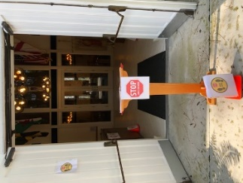 Outside (weather permitting) 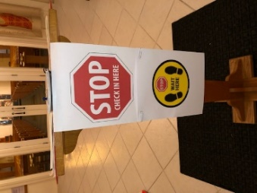 Inside

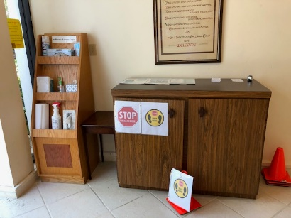 Sanitation & Safety Supplies & TEMP MONITOR Station 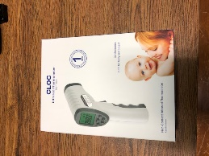

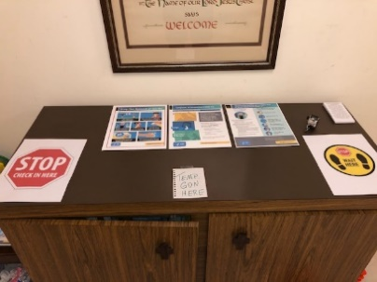 CDC posters at Temp Station

Signs posted at both buildings inside & outside on doors or bulletin boards – Church & Parish Hall / School

Waiting area on opposite side with posters & Sunday program/bulletin pick-up area & recycle bin.

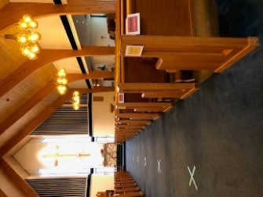 

**PEW AVAILABLE**

**3-4 People Only**

Pews marked 3-4 to a pew, unavailable pew seats indicated by ropes on seat cushions & are across from marked X. Main center aisle is marked 6-foot separation with 360 degree safe area.

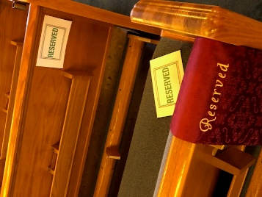 Reserved seating for Videographer on left side & Soloist on right side near piano/organ.

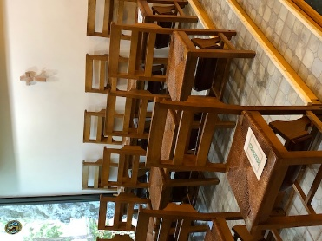 Choir area has only 3 seats available for GUESTS

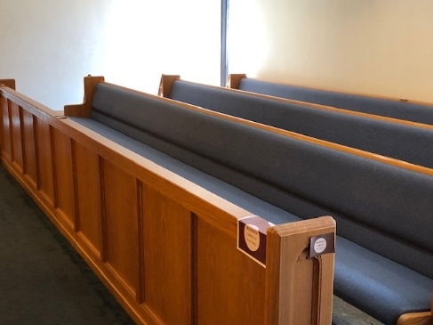 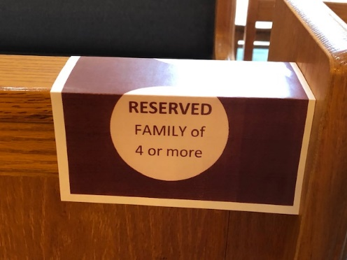

East transept is for Family Units of 4 or more people, available pews (first & third) are marked accordingly.

This area receives communion first, lining up by altar rail awaiting direction to step-up to marked area for receiving communion, across from designated clergy area to give a wafer in hand only (extended arms of both)

Printed programs are located opposite Safety Station in pamphlets rack for convenient pickup and with recycle bin for deposit.

View page 15 & 16 for diagrams of Church and Parish Hall / School

**Note: Training of needed volunteers (altar guild, lectors, safety check-in screening, ushers) is being conducted through email instructions, direct phone calls, zoom when necessary and a mock-up mass rehearsal will be conducted 6/13/20.**

***St. David’s RESPONSES - Diocesan “SEASON II Church Re-Entry Checklist***

1. Submit in writing (to Canon John Tidy or Cris Valdes, COO, Bishop’s Office) affirmation that clergy and Vestry have read the document: “On Being Faithful – Guidelines for the Way Forward in this Season of COVID-19”. **1st draft 5/26/20**

* **Hoping to have complete to send in by this Friday 6/12 so that the diocese has time to look at it and send approval by 6/15 so that we can notify people on 6/19 of possible opening 7/05/20 providing diocesan based on covid percentages.**

1. Submit names and contact information of the re-entry planning committee to Canon John Tidy or Cris Valdes. **DONE**
2. Submit the Financial Survey to Cris Valdes. **What is this? Where is this?**
3. Disseminate and collate results of the Congregational Re-Entry Survey. **DONE & results to Fr. Thomas for Vestry**
4. Submit re-entry plans to Canon Tidy two weeks in advance of re-entry date for approval. **Dates as above**
5. On the parish website, post the executive summary and PowerPoint of the *On Being Faithful* document and/or present this information via Zoom to members of the congregation. **DONE**
6. Prepare and send a re-entry preparation letter to the members of the congregation (sample provided). **In progress**
7. Create, prepare, and post indoor and outdoor signage (sample provided). **DONE**
8. Prepare “pre-production” notebook that specifically outlines all steps to re-entry. **DONE**
9. Order necessary supplies (hand sanitizers/stations; face masks; paper towels; general disinfectant sprays/cleaners; tissues; tape for marking appropriate distancing/seating. **DONE**
10. With ushers, greeters, altar guild, acolytes, etc. practice holding a service in advance of the first Sunday you resume in-person worship. **Mock staging in progress & on 6/13/20**

**Specific to Buildings**

The following church building and office use guidelines must be followed:

* Prior to re-entry thoroughly clean the entire church building, including pews, bathrooms, doorknobs, light switches, stair railings, and microphones. **DONE & Deep cleaning scheduled 1 week prior to re-opening – tentatively 6/29 & 6/30.**
* Flush water pipes by running all faucets 20 minutes. **DONE**
* Flush duct work of HVAC system by running HVAC for one full day prior to re-entry and ensure air filters are new or clean. **DONE**
* Staff members & members of the congregation must continue to follow social distancing & sanitary guidelines. **DONE**
  + Maintaining six feet of separation thru 360° between individuals
  + Wearing face masks
  + Regular hand washing and sanitizer use
  + Regular disinfection of common surfaces including doorknobs, countertops, phone and office electronics

***-CONT.-***

* Regularly clean/disinfect building between user groups, especially high-touch surfaces. **OK – DONE**
* Creating an emergency plan for possible outbreak and how you might respond in care, communication, and in cleanliness.
* Maintaining a visitor log (phone numbers and email addresses) for all who enter the building in the event that they may come in contact with someone with the disease and reporting is required. This log must be thoroughly managed and checked daily. **OK – DONE**
* Establish an online registration process for worship time attendance. This registration serves to coordinate capacity and as a waiver of liability. **Established that whomever comes 1st week must skip a week before return.**

**The following building and office use guidelines are advised:**

* Removing all non-essential items from rooms so that there are fewer surfaces to touch. **DONE**
* Staff members continue to be permitted to work from home. **OK**
* Keeping in-office functions as minimal as possible, only to ensure essential operations. **OK**
* Posting signs outlining COVID-19 symptoms. **DONE**
* Maintaining appropriate stocks of tissue, soap, hand sanitizer, and disposable towels for drying hands. **DONE**
* Consider allowing building users/rental groups to return only on the condition that they are able to observe gathering limits and hygiene protocols. **DONE & meeting to be arranged with AA/Alanon leaders tentatively week of beginning July.**

**Specific to Worship**

The following worship guidelines must be followed:

* All common surfaces must be cleaned before and after worship, including doorknobs, countertops, pews, electronics, and eucharistic vessels. **DONE**
* Training of greeters and ushers to be “safety ministers” who are at the front door ensuring people are wearing masks, avoiding crowding and traffic bottlenecks; and are directing dismissal to avoid the same. **DONE**
* Wearing of non-surgical masks is required. Please consider having a supply for those who arrive without one. **DONE**
* No nursery or in-person Sunday school or coffee hour following the service. **OK**
* No physical touching during the passing of the peace. **OK**
* No passing of the offering plate through the pews. **OK (plates are located at rear of nave for self-service)**
* No singing. **OK**

***-CONT.-***

* Allow for only one person (presider) to prepare the Eucharistic table, touching cruets, distribution of Communion Bread. Cup will not be administered. **OK**
* Households must sit at least six feet apart, 360 degrees. **OK**
* Removal of prayer books, hymnals and bibles from pew racks; use of single-use bulletins (that are picked up rather than handed out) or sending a digital copy for people to access on their personal devices. **OK - DONE**
* Develop a plan for dismissing worshippers to ensure social distancing as people exit. **Rear pews first, east then west**
* No receiving line following the service. **OK**
* Develop a plan to reduce the number of doors that people must touch to enter & exit the service. **Entry double doors**
* Maintain online worship and formation programming (where it has been implemented prior to re-entry). **OK**
* Limit in-person events and meetings. **OK** **on a case-by-case basis with Fr. Thomas permission or use ZOOM**
* Create method for submission of offerings. **Electronic giving w/Church Envelope Budget Co., bank automatic & electronic giving, checks**

**The following worship use guidelines are advised:**

* Multiple services with fewer attendees. **Possible addition of 1 Sunday service if there is overflow, Tues. 8:30am, Wed. 6:30pm**
* Having people sign up for services in advance. **In progress**
* Create and assign fixed seating to maintain safe distances. **OK - possible in future when regularity is evident**

**Revised Changes USHER Instructions**

**for Re-Gathering after a Pandemic**

**Existing Tasks:**

* Arrive 20 minutes early – Wear a name badge -[**https://www.naagtag.com/episcopalchurch1x3**](https://www.naagtag.com/episcopalchurch1x3)

**Diocesan & St. David’s New Policy:**

* No passing out programs.
* No passing of collection plates.
* No physical contact at the exchange of the peace.
* No transport of offering or communion vessels.

**New routine includes:**

* All volunteers check in with the safety station immediately upon arrival.
* A hand-held counting device will be used to count attendance near the Safety Station.
* Only one interior glass door being opened to accommodate entrance.
* Verbal reminders of where to sit – assist those in need and guest.
* Direct each person, couple, or family-unit to fill in the seats at the front.
  + Seating is designated **maximum 3-4** to a marked pew
  + Family-units of 3+plus are to be directed to the east transept
* Communion recipients begin with west choir transept, followed by east family-unit transept, followed by the front center aisle pews; east side (left side facing altar) alternating to west side (right side facing altar), continuing in this manner towards the back.
* Exiting for Recessional begins with the rear left pew and alternates to the left moving forward to the altar. Open both doors and vacate area.

**New Request:**

* If able, 8am Usher assist with sanitation before next mass.
* If able, 10am Usher assist with sanitation after the mass.

**Safety & Check-In Instructions for Volunteers**

**for Re-Gathering after a Pandemic**

*(2-3 people – a Warden or trained Safety Volunteer)*

**Existing Tasks & Following New Criteria:**

* Wear a name badge - <https://www.naagtag.com/episcopalchurch1x3>

**Diocesan & St. David’s New Policy:**

* Must wear a facemask
* No physical contact.
* All volunteers check in with the safety station immediately upon arrival.

**New routine includes:**

* **1st** Checkpoint – Temperature Check – Waiting areas indicated by orange cones
* **2nd** Checkpoint – (can be incorporated with 1st Checkpoint) – Ascertain “Member” or “Visitor”
  + Ask if they have received/read/understood policy **&** if they can answer NO to questions.
    - If a regular member refer to Database Log-In Volunteer
    - If a visitor refer or gather & write their name/contact info in Visitor Log
      * Have them initial information with pencil (place in receptacle after)
* **3rd** Checkpoint – Database Log-In – Place mark **X** next to individual’s name either under 8am (left column) or 10am (right column).

**Note:** you may participate in mass if you have been checked in – remain in building, exit quickly.

**New Request:**

* If able, 8am Safety Check-In Volunteer assist with sanitation before next mass.
* If able, 10am Safety Check-In Volunteer assist with sanitation after the mass.

**Screening Checklist & Health Questionnaire**

**--for Visitors, Staff, Volunteers, Public Attendees—**

**ALL** individuals entering the building must:

* wear a facemask while in the building & during their entire attendance
* submit to temperature check; under 100.4° F
* answer 2 questions: 1.) ***have you had any symptoms or tested positive for covid-19*** ; 3.) ***have you been around anyone who has tested positive or who has exhibited symptoms of covid-19.***
* be logged into database (per mass) **Or** guests submit contact information in visitors log
* restrict activity to 1-2 areas of building

Do you, the individual, have any of the following respiratory symptoms?

* Cough
* Shortness of breath

***OR*** at least **TWO** of these symptoms

--Fever --Chills --Repeated shaking with chills --Muscle pain --Headache --Sore Throat

--New loss of taste or smell --New Respiratory Illness --Vomiting --Diarrhea

You must be able to have a **NO** response to the following questions pertaining to the last 14 days:

* Have you returned from any of these countries: China, Europe, Iran, South Korea?
* Have you traveled to or been in close contact with anyone diagnosed, infected or tested positive?

*Notes:*

*These guidelines are to:*

* *Prevent a shutdown procedure of all buildings & assemblies if someone is or contracts covid-19.*
* *To help keep yourself and others healthy and safe.*

*If you are ill or do not meet the above health scan, seek medical attention.*

*If you have an existing at-risk medical condition, stay home.*

*If you have to go out, wear a mask & wash your hands often for 20 seconds with soap.*

*Otherwise….Stay Home. Stop the Spread. Save Lives.*

***Wavier***

***This memo along with our original survey guidelines will serve as your waiver & reservation only when you return a response that you have read and understood the plan in its entirety to the Parish Office to Suzanne Riddle at*** [***saintdavidschurch@comcast.net***](mailto:saintdavidschurch@comcast.net) ***one week prior to re-opening date.***

***Reservations***

***You will be notified which Sunday mass and time you are scheduled for by email thereafter.***

**Social Media & E-News Information**

Upon Diocesan approval of our EEP, using our Social Media platforms and E-Newsletter distribution system, a memo will be distributed to all household informing them of our plan details as it pertains to each individuals responsibility to re-gather, for keeping everyone a safe and healthy as possible.

**Notes:**

* On-going communication with membership via bi-weekly & weekly newsletters
* Individual phone calls to those without on-line presence
* Social media via FB and website for continual up-to-date communication
* Youtube Channel for posting of mass videos, specials, and announcements along with weekly and periodic messages

**Procedures for Shutdown & Deep Cleaning**

* Diocesan mandate due to increased county statistics
* Quarantine (14-day) after an outbreak or positive case
  + Contact tracing begins through CDC/Health Department
  + Immediate Shutdown and Deep Cleaning
  + Immediate notification of all members of closure
  + Subsequent notification of all members with re-opening information

“A contact investigation often starts with a phone call to a [CDC Quarantine Station](https://www.cdc.gov/quarantine/quarantinestationcontactlistfull.html) or from the patient, hospital or Health Department.”

“CDC does not release any information about the index patient or the contacts to anyone other than public health staff working on the investigation.”

“This information is protected, and access is strictly limited to public health use.”

* Whether an individual has contracted Covid or has any other medical or personal issue is considered private, unless they specifically request that they be put on a prayer list their name/information is not to be divulged or disseminated in any manner. That individual is henceforth referred to as a member or been associated with St. David’s (non-specific as to school or church or community group).

